14
Managing Windows Update Services
This chapter covers the following recipes:
- Exploring WMI architecture
- Exploring WMI Name Spaces
- Exploring WMI Classes
- Obtaining WMI Class instances
- Using WMI Methods
- Using WMI Events
- Implementing Permanent WMI eventing
- Detecting USB Insertion

Introduction

The systems used in the chapter
This chapter uses two Hyper-V host systems, HV1 and HV2 – both domain-joined servers in the Reskit.Org domain. You also use a domain-joined host, SRV1. Finally, you make use of a domain controller in the domain (DC1), so that host must on line as well. The hosts used in this chapter are as shown here:
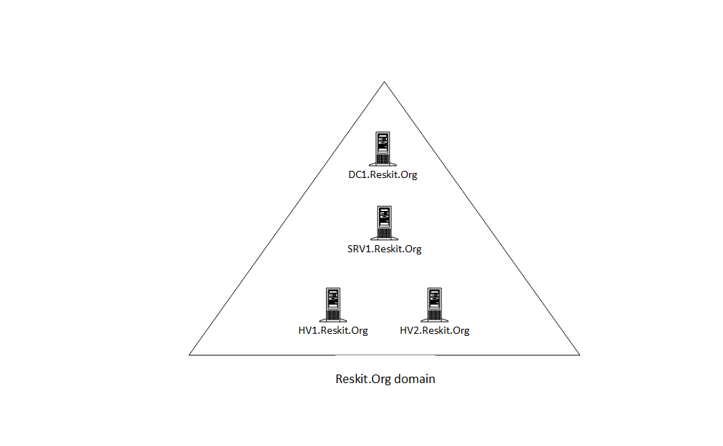
Figure 11.1: Host in use for this chapter
Insert image B18878_11_01.png

Exploring WMI architecture

Getting ready

How to do it...

How it works...

There's more...

Exploring WMI namespaces

Getting ready

How to do it...

How it works...

There's more...

Exploring WMI Classes

Getting ready

How to do it...

How it works...

There's more...

Obtaining WMI Class Instances

Getting ready

How to do it...

How it works...

There's more...

Using WMI methods

Getting ready

How to do it...

How it works...

There's more...

Usinging WMI Events

Getting ready

How to do it...

How it works...

There's more...

Implementing Permanent WMI eventing

Getting ready

How to do it...

How it works...

There's more...

Detecting USB Disk Insertion

Getting ready

How to do it...

How it works...

There's more...

